Nepal College of Information Technology
Assessment
Spring 2010
Program : BE ELX/CE/IT Time : 3 hrs
Semester : Spring (IV) FM : 100
Subject : Engineering Math-IV PM : 50

- Candidates are requested to give their answer as far as practicable in their own words.
- The figure in the margin indicates the full marks
- Attempt ALL question
1. a) Define harmonic function. Prove that u = y³-3x²y is a harmonic function. Determine its harmonic conjugate v of function f(z). 8
b) State Canchy Integral formula. Use it to evaluate the integral 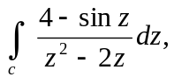 where c is the square with vertices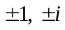. 7
2. a) i) Determine the location and order of zeros of the function f(z) = (z⁴-z²-6)³. 4
ii) Define singular point. Find the singular points of 2z⁻³ - z⁻¹. 4
b) Define one dimensional wave equation. 7
3. a) Find the temperature u(x, t) in a slab whose ends x=0 and x=L are kept at zero temperature and whose initial temperature f(x) is given by
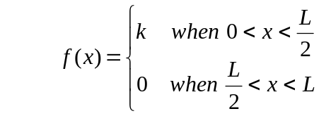 7
b) Find the deflection u(x, t) of a string of length 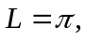 where c²=1, the initial velocity is zero and the initial deflection is 0.01 sin 3x. 7
4. a) Define Z-transform . Find Z(e^{-iat}) and hence deduce the values of Z (cos at) and Z (sin at). 8
b) Find the inverse Z-transform of 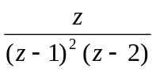 7
5. a) Solve using Z-transform
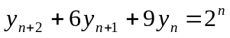where 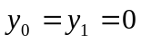 7
b) Maximize
8
6. a) Find fourier transform of the function
f(x) = 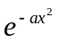 where a>0.
OR
Find the Fourier cosine transform of f(x) = 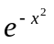.
b) Show that
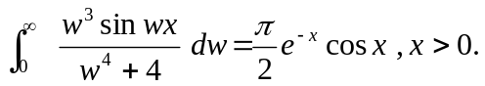
7. Attempt all:
i) Solve 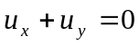 by separation of variable method.
ii) Find fourier Sine integral of f(x) =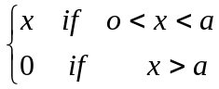
iii) Find the Z-transform of t² e^{-5t}.
iv) Show that 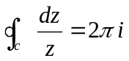where c is unit circle counter clockwise.
v) Find a tangent vector and unit tangent vector of 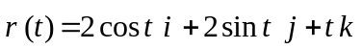 at P(2, 0, 0).

